**Exercise 8:**

**Simulate the lifecycle stages for UI design using the RAD model and develop a small interactive interface using Axure RP**

**AIM:**

The aim is to demonstrate the lifecycle stages of UI design via the RAD model and develop a small interactive interface employing Axure RP.

**PROCEDURE:**

**Tool Link: https://www.axure.com/**

**Simulating the Lifecycle Stages for UI Design Using the RAD Model**

RAD Model (Rapid Application Development): The RAD model emphasizes quick development and iteration. It consists of the following phases:

1. Requirements Planning:

○ Gather initial requirements and identify key features of the UI.

○ Engage stakeholders to understand their needs and expectations.

2. User Design:

○ Create initial prototypes and wireframes.

○ Conduct user feedback sessions to refine the designs.

○ Use tools like Axure RP to develop interactive prototypes.

3. Construction:

○ Develop the actual UI based on the refined designs.

○ Perform iterative testing and feedback cycles.

4. Cutover:

○ Deploy the final UI.

○ Conduct user training and support.

**Axure RP Interactive Interface Development**

**Phase 1: Requirements Planning**

1. **Identify Key Features:**

○ Navigation (Home, Product Categories, Product Details, Cart, Checkout, Order Confirmation, Order History)

○ User actions (Browsing, Searching, Adding to Cart, Checkout, Tracking Orders)

2. **Create a Requirements Document:**

○ List all features and functionalities.

○ Document user stories and use cases.

**Phase 2: User Design**

1. **Install and Launch Axure RP:**

○ Download and install Axure RP from Axure's official website.

○ Launch the application.

2. **Create a New Project:**

○ Go to File -> New to create a new project.

○ Name the project (e.g., "Shopping App Interface").

3. **Create Wireframes:**

○ Use the widget library to drag and drop elements onto the canvas. ○ Design wireframes for each screen:

■ Home Page

■ Product Categories

■ Product Listings

■ Product Details

■ Cart

■ Checkout

■ Order Confirmation

■ Order History

4. **Add Interactions:**

○ Select an element (e.g., button) and go to the Properties panel.

○ Click on Interactions and choose an interaction (e.g., OnClick).

○ Define the action (e.g., navigate to another screen).

5. **Create Masters:**

○ Create reusable components (e.g., headers, footers) using Masters. ○ Drag and drop masters onto the wireframes.

6. **Add Annotations:**

○ Add notes to describe each element's purpose and functionality.

○ Use the Notes panel to add detailed annotations.

**Phase 3: Construction**

1. **Develop Interactive Prototypes:**

○ Convert wireframes into interactive prototypes by adding interactions and transitions.

○ Use dynamic panels to create interactive elements (e.g., carousels, pop-ups). 2. **Test and Iterate:**

○ Preview the prototype using the Preview button.

○ Gather feedback from users and stakeholders.

○ Make necessary adjustments based on feedback.

**Phase 4: Cutover**

1. **Finalize and Export:**

○ Finalize the design and interactions.

○ Export the prototype as an HTML file or share it via Axure Cloud.

2. **User Training and Support:**

○ Conduct training sessions to familiarize users with the new interface.

○ Provide documentation and support for any issues.

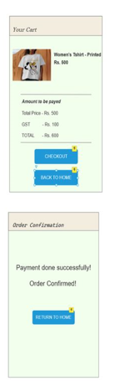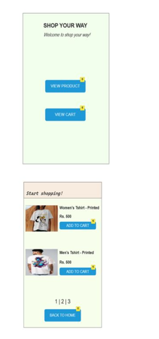**OUTPUT:**